**SQL Case Study 3: Data Bank**



**INTRODUCTION:**

Neo-Banks are a recent development in the financial sector; they are new banks that solely operate online.

I believed that there should be some kind of connection between the digital world, these new age institutions, and cryptocurrencies.

So I made the decision to start a new project called Data Bank!

Customers of Data Bank receive cloud data storage allotments that are directly related to the balances in their accounts. The Data Bank team needs your assistance since this business model comes with some intriguing drawbacks.

This case study focuses on metrics calculations, business growth, and smart data analysis to assist the company more accurately estimate and plan for the future.

**SCHEMA USED**

|  |  |
| --- | --- |
| regions | |
| region_id | int |
| region_name | varchar |

|  |  |  |
| --- | --- | --- |
| customer_transactions | | |
| customer_id | int |
| txn_date | | date |
| txn_type | | varchar |
| txn_amount | | int |

|  |  |
| --- | --- |
| customer_nodes | |
| customer_id | int |
| region_id | int |
| node_id | int |
| start_date | date |
| end_date | date |

**CASE STUDY QUESTIONS**

1. How many different nodes make up the Data Bank network?



SELECT count(DISTINCT node_id) AS unique_nodes

FROM customer_nodes;

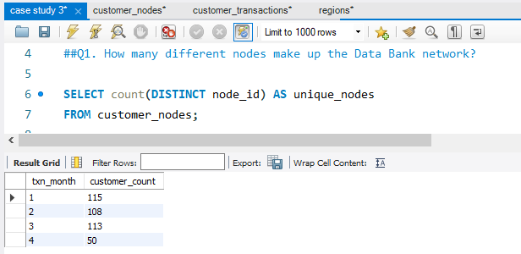

1. How many nodes are there in each region?



SELECT region_id,

count(node_id) AS node_count

FROM customer_nodes

INNER JOIN regions USING(region_id)

GROUP BY region_id;

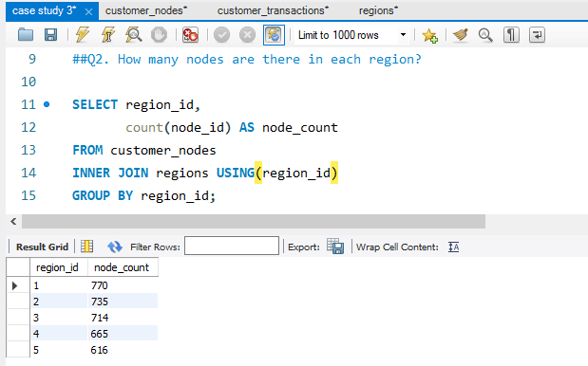

1. How many customers are divided among the regions?

SELECT region_id,

count(DISTINCT customer_id) AS customer_count

FROM customer_nodes

INNER JOIN regions USING(region_id)

GROUP BY region_id;

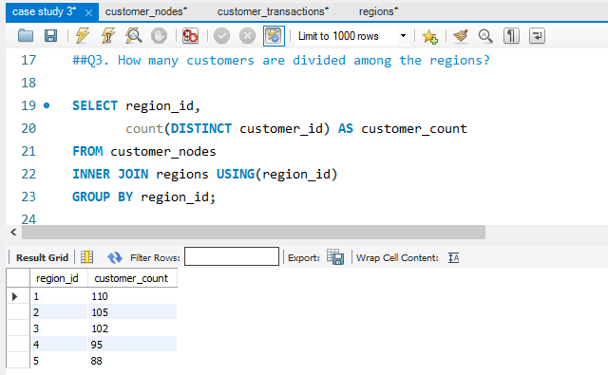

1. Determine the total amount of transactions for each region name.



SELECT

region_name, SUM(txn_amount) AS 'total transaction amount'

FROM

regions, customer_nodes, customer_transactions

WHERE

regions.region_id = customer_nodes.region_id

AND customer_nodes.customer_id = customer_transactions.customer_id

group by region_name;group by region_name;

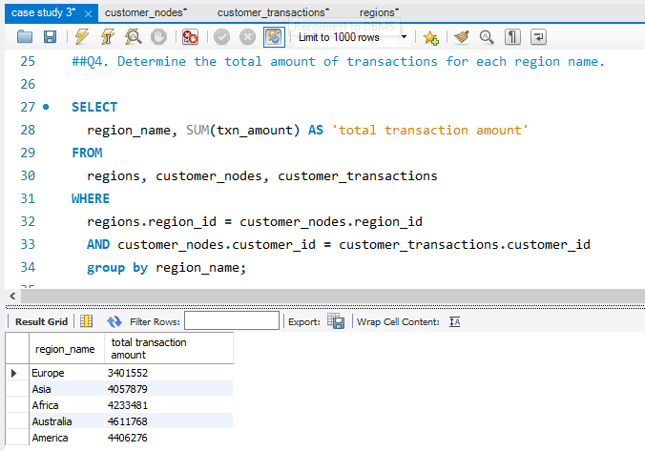

1. How long does it take on an average to move clients to a new node?



SELECT round(avg(datediff(end_date, start_date)), 2) AS avg_days

FROM customer_nodes

WHERE end_date!='9999-12-31';

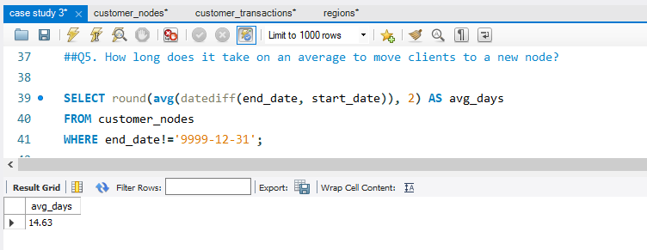

1. What is the unique count and total amount for each transaction type?



SELECT txn_type,

count(*) AS unique_count, sum(txn_amount) AS total_amont

FROM customer_transactions

GROUP BY txn_type;

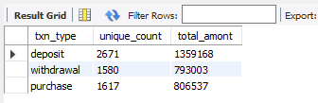

1. What is the average number and size of past deposits across all customers?



SELECT round(count(customer_id)/

(SELECT count(DISTINCT customer_id)

FROM customer_transactions)) AS average_deposit_count,

concat('$', round(avg(txn_amount), 2)) AS average_deposit_amount

FROM customer_transactions

WHERE txn_type = "deposit";

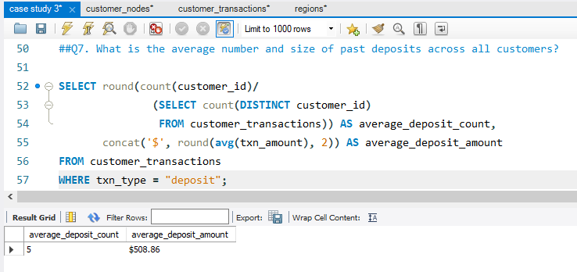

1. For each month - how many Data Bank customers make more than 1 deposit and at least either 1 purchase or 1 withdrawal in a single month?



WITH transaction_count_per_month_cte AS

(SELECT customer_id,

month(txn_date) AS txn_month,

SUM(IF(txn_type="deposit", 1, 0)) AS deposit_count,

SUM(IF(txn_type="withdrawal", 1, 0)) AS withdrawal_count,

SUM(IF(txn_type="purchase", 1, 0)) AS purchase_count

FROM customer_transactions

GROUP BY customer_id,

month(txn_date))

SELECT txn_month,

count(DISTINCT customer_id) as customer_count

FROM transaction_count_per_month_cte

WHERE deposit_count>1

AND (purchase_count = 1

OR withdrawal_count = 1)

GROUP BY txn_month;

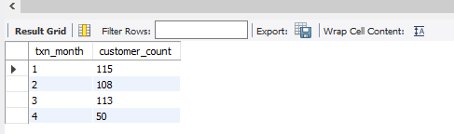

Hi,

Thank you for providing the instructions and guidance throughout the project. I learned a lot from this real-world scenario case study.

I'd love to connect with you on

LinkedIn: ( <https://www.linkedin.com/in/nikhil-kumar-roy/> ) and share my GitHub profile: ( <https://github.com/NikhilRoyDA> ), where you can find my work on this and different case study.

Thanks again for your support and guidance. I appreciate your help in my learning journey.

Best regards,

Nikhil Kumar Roy

